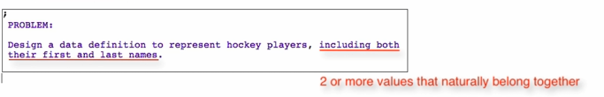

* This is the signal that you decide to have compound data definition

Go to design recipe ->

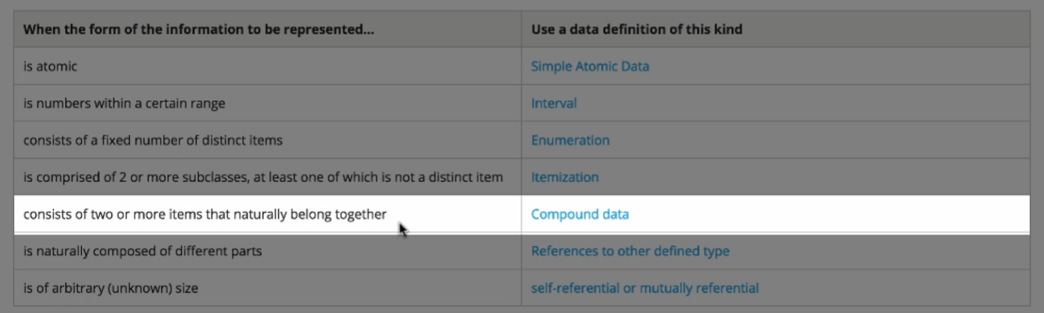

-> Compound data (structures)

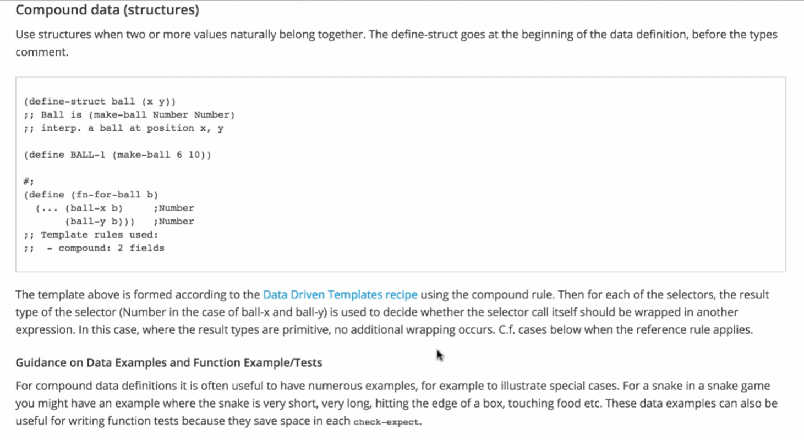

Compound Data

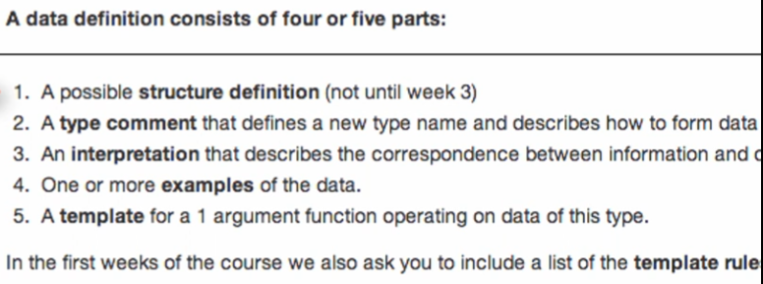

**Structure definition**



**Type comment**



* Something is a player if it is a make-player and the first field/arg is a string, and the second field/arg is a string

**Interpretation**

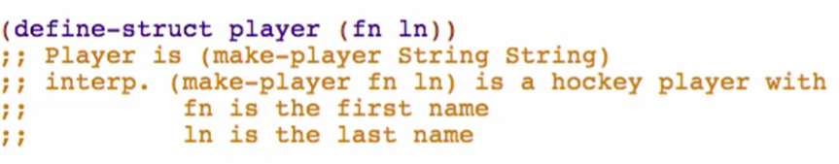

**Examples**



**Template**

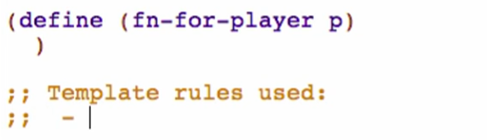

Go to design recipe -> 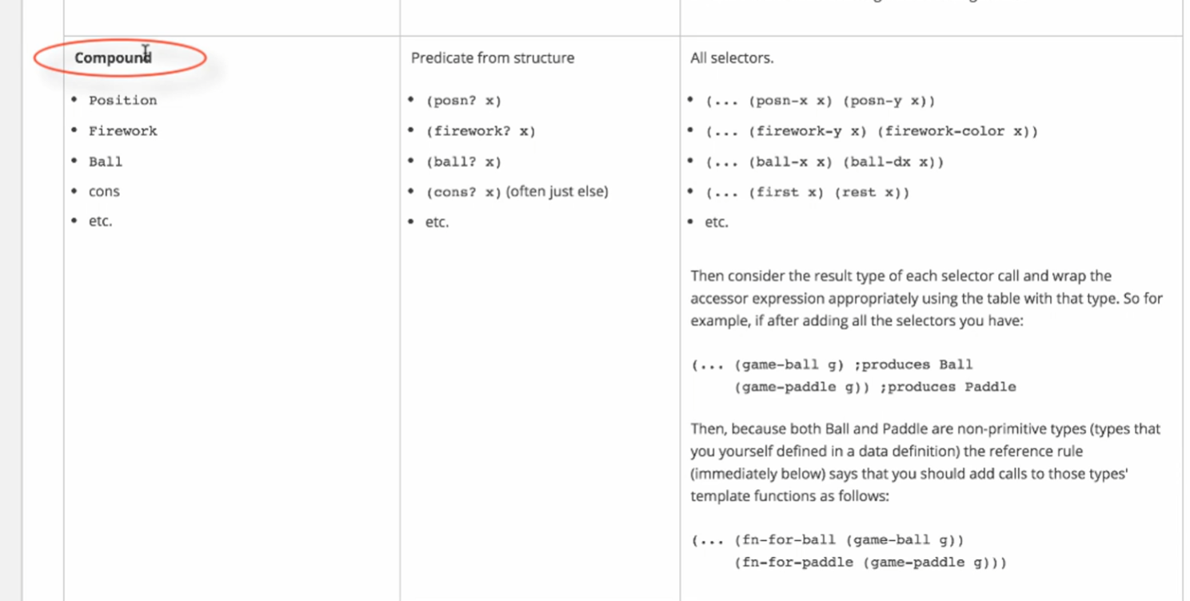

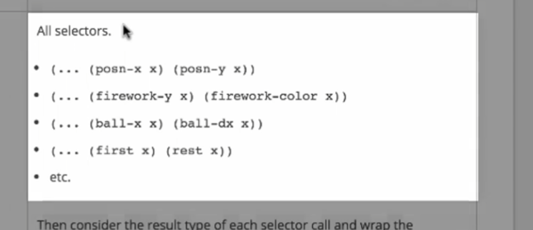

Going back to Racket:

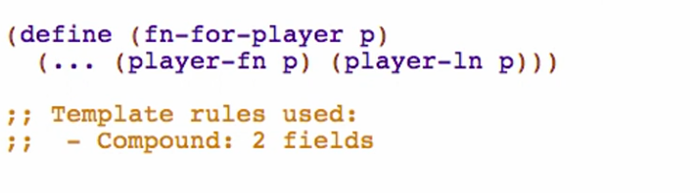

Check design recipe & consider the result type of each selector

